**World Quant University**

**Professor: Ritabrata Bhattacharyya**

**Python II**

Nikolas Lippmann Pareschi - [nikolaslippmann@gmail.com](mailto:nikolaslippmann@gmail.com)

**Project 2:  Choosing a Stock Exchange**

1. Write a python program that prompts the user to choose any five stock exchanges of the world (whose data is available on Google Finance, Yahoo Finance, Quandl, CityFALCON, or another similar source.

This was doing accordingly to this logic:

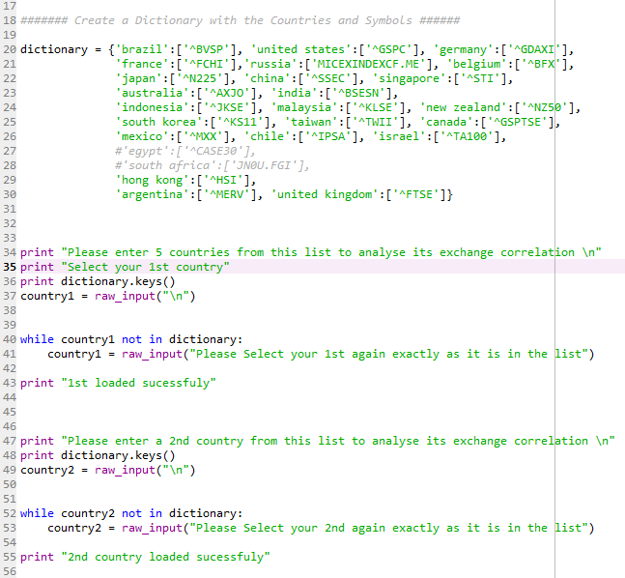

1. For each such market, let the program automatically choose the relevant Market Index (say S&P500 for USA, CNXNIFTY for India, HANGSENG Index for Hong Kong etc)

The program then kept the values of the dictionary keys in the symbols vars:

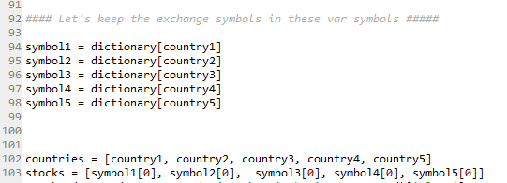

1. Download data for the last 10 years for each of the Indices.





PS: I got a little more than 10 years so I could better analyze the rolling correlations in the year of 2008.

1. Calculate Correlation Coefficients of monthly returns between each pair of indices

First we calculated the log returns. Then we computed the correlations, After that we changed the frequency to monthly data and we computed the correlations again (I understand it was unnecessary to do the daily correlations).

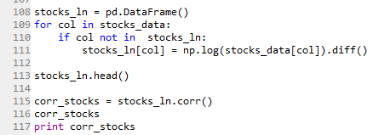 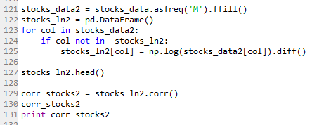

Using seaborn we ploted several heat maps:

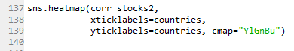

We did some analysis about developed x emerging markets, developed markets auto-correlations, emerging markets auto-correlation and local correlation. I posted this in Piazza too:

Developed x Emerging markets provide some diversification power:

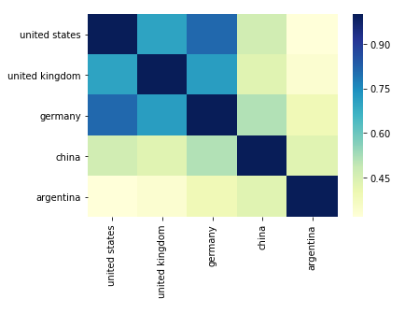

I was unable to see a clear pattern considering regions (Europe x Latin America):

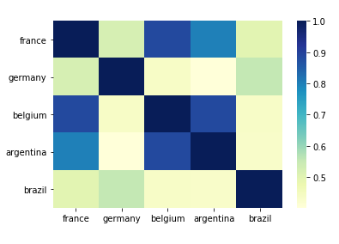

Developed markets presents high correlation among them:

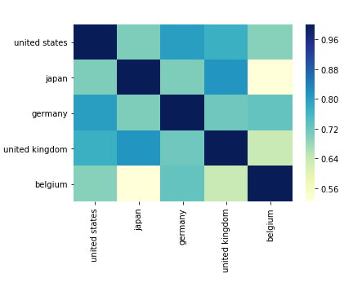

Same pattern in the Emerging Markets (Brazil exception possibly due to the Dilma - the president in 2010-2015 effect.

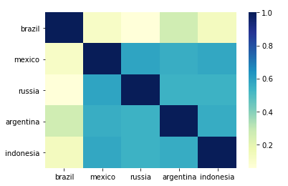

All these correlations considered the data in all years.

1. Plot the results in a suitable graphical format that represents the trends in the data and their interdependence

We ploted all the combinations of correlations (C5,2) in individual graph and then we ploted in a single graph:

Individual correlations examples:

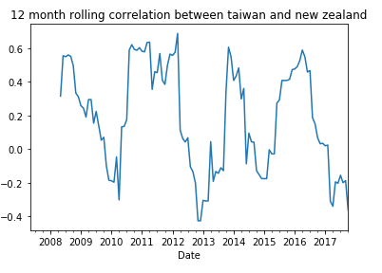 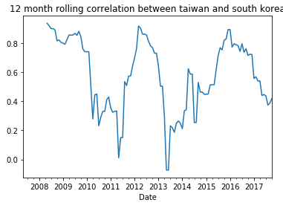

Example of code for the individual cases

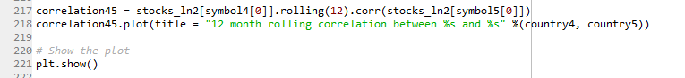

All correlations in a single graph:

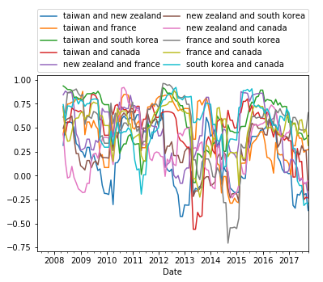

Code: 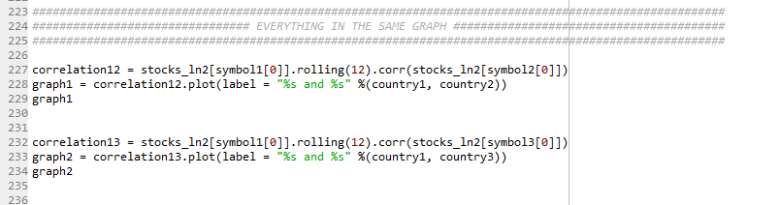

…

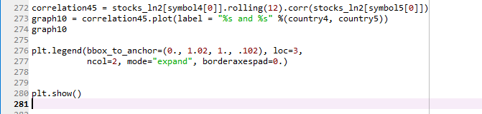

I also plotted the scatterplot of returns. In the diagonal we have the histogram of the log returns of each selected exchange. The log returns and the scatter plot graph I discovered watching this nice youtube video:

<https://www.youtube.com/watch?v=isCP0P9eSVY&list=FLnX-EO-5DnYYKQECuebrjVQ&index=1>

